**Use case diagram**

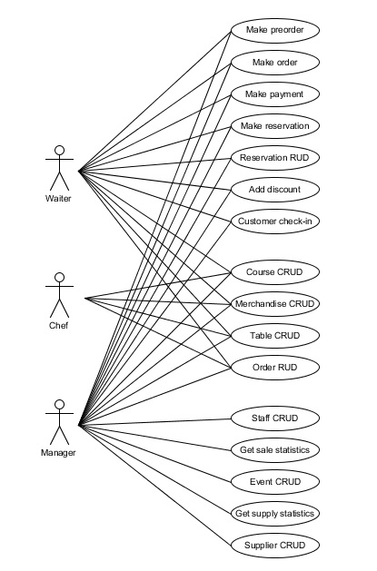Use case diagram is the most important component in order to design a good program. There were no time spared in making the best out of the information provided. Based on the event tables and workflow of the company the use cases were established. There are three actors for this system: manager, waiter and chef. The visibility of the use cases where established as the manager will have access to every use case, waiter will not be able to access, Staff CRUD, Get sales statistics, Event CRUD, Get supply statistics, Supplier CRUD and chef will have access only to few use cases – Course CRUD, Merchandise CRUD, Table CRUD, Order RUD. Corse CRUD, Merchandise CRUD and Table CRUD use cases are accessible to everyone to let company’s staff work together when new merchandise, tables or courses are brought in the bar / restaurant and needs to be registered. This way it will save a lot of time.

As long as the use cases were completed there were no doubts about the requirements for the new system and the designing of use cases could begin.